**Programming the thread creation**

1. Writing a program in Java by extending the **Thread** class

**package** Pack3;

**public** **class** MyThread **extends** Thread

{

**public** **void** run()

{

System.***out***.println("concurrent thread started running..");

}

**public** **static** **void** main( String args[] )

{

MyThread mt = **new** MyThread();

mt.start();

}

}

// Output: Concurrent thread started running

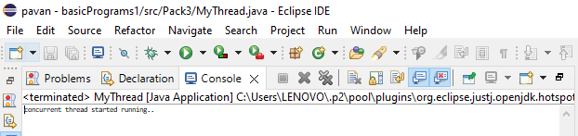

1. Writing a program in Java by implementing the **Runnable** interface

**package** Pack3;

**public** **class** MyRunnableThread **implements** Runnable{

**public** **static** **int** *myCount* = 0;

**public** MyRunnableThread(){

}

**public** **void** run() {

**while**(MyRunnableThread.*myCount* <= 10){

**try**{

System.***out***.println("Expl Thread: "+(++MyRunnableThread.*myCount*));

Thread.*sleep*(100);

}

**catch** (InterruptedException iex) {

System.***out***.println("Exception in thread: "+iex.getMessage());

}

}

}

**public** **static** **void** main(String a[]){

System.***out***.println("Starting Main Thread...");

MyRunnableThread mrt = **new** MyRunnableThread();

Thread t = **new** Thread(mrt);

t.start();

**while**(MyRunnableThread.*myCount* <= 10){

**try**{

System.***out***.println("Main Thread: "+(++MyRunnableThread.*myCount*));

Thread.*sleep*(100);

}

**catch** (InterruptedException iex){

System.***out***.println("Exception in main thread: "+iex.getMessage());

}

}

System.***out***.println("End of Main Thread...");

}

}

